AF 52
Synopsis

IOT – Based Smart Energy Monitoring

Submitted in partial fulfilment of the requirements of the degree of
Bachelor of Technology
In
Information Technology

by
Janhavi Bhanusali [EU2224001]
Ayush Desai [EU2224005]
Hiteshi Dhandare [EU2224006]

Under the Guidance of
Mr. Manthankumar Surti
Assistant Prof. of Information Technology, SJCEM



DEPARTMENT OF INFORMATION TECHNOLOGY
ST. JOHN COLLEGE OF ENGINEERING & MANAGEMENT
UNIVERSITY OF MUMBAI
2025-2026



Certificate of Approval

This is to certify that of Janhavi Bhanusali (05), Ayush Desai (10), Hiteshi Dhandare (12) are bonafide students of B. Tech in Information Technology- Department, St. John College of Engineering and Management, Mumbai. They have satisfactorily completed the requirements of Synopsis as prescribed by ST. JOHN COLLEGE OF ENGINEERING AND MANAGEMENT (An Autonomous College affiliated to University of Mumbai), while working on “IOT – Based Smart Energy Monitoring”.

Signature :  Name : Mr. Manthankumar Surti  Assistant Professor of IT | Signature :  Name :Dr. Arun Saxena  Head of Department of IT

Signature:
Name : Dr. Kamal Shah Principal,
St. John College of Engineering and Management.

Declaration

We declare that this written submission represents our ideas in our own words and where others ideas or words have been included, we have adequately cited and referenced the original sources. we also declare that we have adhered to all principles of academic honesty and integrity and have not misrepresented or fabricated or falsified any idea/data/fact/source in our submission. we understand that any violation of the above will be cause for disciplinary action by the Institute and can also evoke penal action from the sources which have thus not been properly cited or from whom proper permission has not been taken when needed.

(Signature)
Janhavi Bhanusali [EU2224005]

.
(Signature)
Ayush Desai [EU2224001]

.
(Signature)
Hiteshi Dhandare[EU2224006]

Date:
ACKNOWLEDGEMENT

We owe our deepest gratitude and regards towards the ones who offered their valuable guidance in the hour of need. We would like to express our heartfelt thanks to Dr. Kamal Shah (Principal, St. John College of Engineering and Management) for providing the facilities, encouragement, and constant support that enabled us to successfully carry out this project. Our special thanks go to Dr. Arun Saxena (Head of Department, Department of Information Technology, St. John College of Engineering and Management) for his inspiring suggestions and valuable advice that helped us to a great extent in our work. We take this opportunity to extend our heartfelt gratitude to our guide, Mr. Manthankumar Surti (Assistant Professor of Information Technology, St. John College of Engineering and Management) for his valuable guidance, constructive feedback, and encouragement to question every technical detail. Her useful comments and continuous support during our project discussions have been immensely helpful.

Janhavi Bhanusali [EU2224005]
Ayush Desai [EU2224001]
Hiteshi Dhandare [EU2224006]

ABSTRACT

Unmonitored electrical energy consumption, low power factor conditions, and grid voltage instability pose major challenges to energy efficiency and appliance longevity in modern residential and commercial buildings. Traditional electromechanical and static digital energy meters provide aggregated billing data retroactively at the end of a billing cycle, offering zero real-time visibility into instantaneous line fluctuations, active power surge events, or appliance-level consumption signatures.
This project presents an IoT-Enabled Smart Energy Monitoring, NILM Load Classification, and Voltage Stabilizer Recommender System. The hardware layer utilizes an optocoupler-isolated PZEM-004T multifunction power sensing module interfaced with an ESP32 microcontroller to capture high-frequency single-phase AC parameters—Line Voltage (V), Current Load (A), Active Power (W), and Power Factor (PF). The telemetry stream is transmitted via a lightweight WebSocket/JSON interface to a high-performance React web dashboard.
The software dashboard incorporates four core analytical modules:
- Live Telemetry Dashboard: Featuring real-time auto-scrolling SVG trendlines and dynamic radial gauges for continuous signal visualization.
- Budget Analytics Engine: Forecasting monthly energy costs based on configurable multi-slab regional utility tariff structures ($₹7.3/kWh).
- NILM AI Load Recorder: Capturing transient power signatures during appliance activation events to enable Non-Intrusive Load Monitoring.
- Stabilizer Sizing & Recommendation Engine: Algorithmic determination of required kVA ratings incorporating a $25% inductive surge safety margin and high/low voltage cutoff parameters.
System validation confirmed measurement accuracy within $\pm 0.5\%$ error relative to calibrated reference meters and verified automated rating calculations under variable simulated load profiles. The system successfully transitions energy management from passive retrospective billing to active real-time diagnostics, load classification, and predictive equipment protection.

Keywords - Internet of Things (IoT), ESP32, Non-Intrusive Load Monitoring (NILM), PZEM-004T, Power Quality Analysis, Voltage Stabilizer Recommender, Real-Time Web Telemetry.

C O N T E N T S
- List of Figures i
- List of Tables ii
- Abbreviations and symbols iii

Chapter No. | Topic | Page No.
Chapter 1 | Overview | 8
 | 1.1 Introduction | 8
 | 1.2 Background | 9
 | 1.3 Importance of the project | 9
 | 1.4 Perspective of stakeholders and customers | 10
 | 1.5 Objectives and scope of the project | 10
 | 1.6 Summary
Chapter 2 | Literature Survey & Proposed work | 11
 | 2.1 Introduction | 11
 | 2.2 Literature Survey Table | 11
 | 2.3 Problem Definition | 13
 | 2.4 Feasibility Study | 13
 | 2.5 Methodology Used | 14
 | 2.6 Summary | 14
Chapter 3 | Analysis and Planning | 15
 | 3.1 Introduction | 15
 | 3.2 Project Planning | 15
 | 3.3 Scheduling | 16
 | 3.4 Summary | 17
Chapter 4 | Design & Implementation | 18
 | 4.1 DFD | 18
 | 4.2 Block Diagram | 18
 | 4.3 GUI Screenshot | 19
Chapter 5 | Results & Discussion | 20
 | 5.1 Actual Results | 20
 | 5.2 Future Scope | 20
 | 5.3 Testing | 21
 | 5.4 Deployment | 22
Chapter 6 | Conclusion | 23
 | References | 24

List of Figures

Figure No. | Figure Name | Page No.
1 | System Architecture
2 | NILM Feature Extraction
3 | Project Execution Schedule
4 | Data Flow Diagrams | 19
5 | Complete Block Diagram
6 | Live Telemetry Interface
7 | Budget Tariff Dashboard
8 | Stabilizer Calculator Panel

List of Tables

Figure No. | Figure Name | Page No.
1 | Literature Survey Matrix | 11 to 13
2 | System Feasibility Matrix | 16
3 | Work Breakdown Structure | 20
4 | Sensor Calibration Results
5 | Software Test Suite

Abbreviations and symbols
• IoT – Internet of Things
• ESP32 – 32-bit Microcontroller with Integrated Wi-Fi/Bluetooth
• PZEM – PZEM-004T AC Multifunction Power Meter Module
• NILM – Non-Intrusive Load Monitoring
• CT – Current Transformer
• PF – Power Factor
• RMS – Root Mean Square
• kVA – Kilovolt-Ampere
• kWh – Kilowatt-Hour
• JSON – JavaScript Object Notation
• DFD – Data Flow Diagram

Chapter 1

1.1 Introduction

Energy monitoring and grid instability management are critical concerns for modern residential and commercial electrical infrastructures. Traditional electromechanical and static utility meters provide aggregated billing data retroactively at the end of a billing cycle, leaving consumers without immediate visibility into real-time power consumption, instantaneous power factor degradation, or line voltage fluctuations.
To address these challenges, the IoT-Based Smart Energy Monitoring, NILM Load Classification, and Voltage Stabilizer Recommender System is designed to provide continuous real-time telemetry and intelligent power quality management. The system employs an ESP32 microcontroller integrated with a PZEM-004T electrical sensing module to capture line voltage ($V$), current ($A$), active power ($W$), and power factor ($PF$). Data is streamed via Wi-Fi/Serial JSON payloads to a high-performance React frontend featuring auto-scrolling trendlines, multi-slab utility billing forecasts, transient load event classification, and automated voltage stabilizer rating calculations

1.2 Background

The necessity for intelligent power quality management systems has increased as electronic and inductive motor loads proliferate in modern buildings. Unmonitored low power factor ($PF < 0.85$) leads to excessive line heat, inefficiency, and billing penalties. Furthermore, unstable utility grids subject domestic appliances to severe under-voltage and over-voltage transients. Existing static meters lack real-time granularity, while traditional stabilizer purchasing relies on unscientific guesswork. This project leverages IoT hardware and web analytics to automate energy monitoring, identify load activations, and recommend optimal stabilizer ratings.

1.3 Importance of Project
• Real-Time Visibility: Eliminates hidden energy waste through instantaneous power and voltage streaming.
• Appliance Insights without Sub-Metering: Utilizes Non-Intrusive Load Monitoring (NILM) techniques to identify device activation events from the main feed.
• Automated Equipment Protection: Calculates exact kVA capacity ratings and voltage cutoff bounds for stabilizers using real-time parameter measurements.
• Financial Forecasting: Provides multi-slab tariff projections to prevent end-of-month electricity bill overruns.
1.4 Perspective of stakeholders and customers
• End Users (Households): Receive safe, transparent energy tracking, billing estimates, and automated stabilizer sizing guidance.
• Industrial & Commercial Users: Monitor heavy single-phase loads, prevent power factor surcharges, and protect motors.
• Electrical Technicians & Engineers: Obtain verifiable real-time power parameters and downloadable CSV records for site energy audits
1.5 Objectives and scope of the project
Objectives:
- Design an IoT telemetry node using ESP32 and PZEM-004T for isolated AC voltage, current, and active power sensing.
- Implement a responsive React web dashboard with auto-scrolling SVG chart rendering.
- Formulate a multi-slab regional electricity tariff estimation engine.
- Integrate a NILM signature recorder to detect step-change load activations.
- Develop a stabilizer sizing recommender incorporating a 25% surge margin.
Scope:
The project can be applied to:
- Single-phase residential and commercial AC distribution lines up to 250V and 100A.

1.6 Summary
This chapter outlined the motivation, core technical objectives, and scope of the proposed IoT energy monitoring system. The project moves beyond passive billing to deliver active real-time protection and analytics.

Chapter 2

2. Literature Survey & Proposed Work

2.1 Introduction
This chapter reviews past research in IoT energy metering, power quality sensors, and load disaggregation methods, identifying limitations in existing approaches.
2.2 Literature Survey Table
Sr. No | Title | Author(s) | Year
1 | Nonintrusive Appliance Load Monitoring | Hart, G. W. | 1992
2 | IoT Based Smart Energy Metering | Rahman et al. | 2020
3 | Real-Time Energy Monitoring using PZEM | Rashmi et al. | 2022
4 | Proposed Smart Energy & Stabilizer Recommender | Desai et al. | 2026
2.2 Literature Survey Table
2.3 Problem Definition
Conventional energy meters operate without real-time customer feedback, leading to billing surprises and unmonitored line fluctuations. Consumers face appliance damage during severe grid voltage swings due to improperly sized voltage stabilizers. There is a critical requirement for a single unified system that monitors electrical parameters, profiles appliance loads, and calculates stabilizer requirements.
2.4 Feasibility Study
Before implementation, a feasibility study was conducted to ensure that the proposed system is technically, economically, and operationally viable.
1. Technical Feasibility:
The dual-core ESP32 provides reliable hardware serial communication with the PZEM-004T module. React handles real-time SVG DOM updates efficiently.
2. Economic Feasibility:
Low bill of materials cost using open-source tools makes it economical compared to commercial power analyzers.
3. Operational Feasibility:
Intuitive dashboard UI and automated appliance presets ensure ease of use for non-technical users.

2.5 Methodology Used

The methodology is divided into four main layers:
1. Sensing Layer: Optocoupler-isolated PZEM-004T measures voltage, current, power factor, and active power.
2. Communication Layer ESP32 streams telemetry via Wi-Fi/WebSockets using JSON payloads.
3. Processing Layer: React engine parses data, updates live gauges, and computes multi-slab billing.
4. Application Layer: Provides real-time trendlines, NILM transient recording, and stabilizer sizing recommendations.

2.6 Summary
The literature review highlighted existing research efforts and their limitations. The proposed methodology demonstrates a comprehensive IoT architecture for real-time monitoring, cloud-based data management, and real-time power telemetry. This approach ensures a scalable, efficient, and reliable system suitable for widespread deployment.

Chapter 3
3. Analysis and Planning

3.1 Introduction

The development of a robust hardware-software system for real-time electrical parameter tracking, power quality analytics, and intelligent load disaggregation requires systematic architectural planning and detailed structural decomposition. Passive energy monitoring tools often fail due to improper hardware isolation, sampling latency, or rigid, non-scalable user interfaces. This chapter outlines the detailed analytical framework, hardware and software requirement specifications, component selection criteria, mathematical formulations, software module workflows, risk mitigation strategies, and execution timelines that govern the project.

3.2 Project Planning

Project planning serves as the blueprint for the entire engineering development lifecycle. It ensures that the project progresses through organized, systematic stages, with each sub-module contributing to the final integrated smart energy monitoring and protection platform. The planning process for this project involved the following ten structured stages:

3.2.1 Requirement Analysis: To ensure high-fidelity electrical telemetry and seamless data synchronization between the sensing hardware and the web interface, system requirements were categorized into functional, non-functional, and physical/hardware specifications. Key AC parameters (Active Power, Power Factor, Frequency, and Energy), multi-slab utility tariff structures, transient load signature logs, and stabilizer kVA sizing parameters were formally defined.

3.2.2 Hardware Design and Interfacing: The dual-core 32-bit ESP32 microcontroller was selected as the central edge-processing node due to its high speed and onboard Wi-Fi capabilities. The optocoupler-isolated PZEM-004T v3.0 multifunction power sensing module, along with a 100A split-core Current Transformer (CT), was interfaced via Hardware/SoftwareSerial TTL pins. Circuit design prioritized high-voltage AC optical isolation to safeguard the microcontroller and development team.
3.2.3 Firmware Development: Embedded C++ firmware developed in the Arduino IDE was deployed on the ESP32 to query the PZEM-004T module registers over Modbus-RTU protocol. Operating across hardware dual cores, the firmware executes high-frequency register polling on Core 0 while formatting data into JSON payloads and managing Wi-Fi/WebSocket streaming routines on Core 1.

3.2.4 Telemetry Payload & Communication Engine: A lightweight serial and WebSocket JSON protocol was designed to transmit electrical parameters (V, A, W, PF, Hz, kWh) at 1Hz sampling intervals. This eliminated heavy server overhead and ensured real-time, low-latency data streaming directly from the hardware sensing node to the frontend analytical dashboard.

3.2.5 Web Dashboard & Analytics Interface Design: A modern, single-page web dashboard was engineered using React 18, Vite, and Tailwind CSS. The frontend provides real-time visualization through dynamic radial arc gauges, auto-scrolling live SVG trendlines (sliding window of 30 samples), a multi-slab billing calculator, a Non-Intrusive Load Monitoring (NILM) transient recorder, and a voltage stabilizer sizing recommendation tool.

3.2.6 Analytical Engine & Algorithm Integration: Core mathematical models were implemented directly into the web analytics suite:
- Tariff Engine: Computes real-time run rates and daily expense projections based on regional multi-tier pricing structures (₹7.30/kWh).
- NILM Engine: Monitors power step-changes (Delta P) to log appliance activation signatures in a live event ledger.
- Stabilizer Engine: Computes required apparent power capacity (kVA) including a $25\%$ surge margin and selects appropriate high/low voltage cutoff ranges.

3.2.7 Integration of System Components: This stage linked the physical AC distribution line, PZEM-004T module, ESP32 edge device, JSON communication stream, and React web application into a unified monitoring ecosystem. Communication links were systematically verified to ensure seamless end-to-end data synchronization.

3.2.8 Testing and Debugging: Rigorous unit, integration, and performance testing routines were conducted. Sensor readings were validated against calibrated digital multimeters and clamp meters under both resistive (e.g., incandescent bulbs, heaters) and inductive (e.g., motor pumps, fans) loads. Issues such as WebSocket reconnect drops, chart DOM render lag, and baud rate mismatches were successfully resolved.

3.2.9 Deployment and Continuous Integration: The frontend application was deployed on the Vercel cloud platform, providing global accessibility across desktop and mobile browser interfaces. GitHub was utilized for source code repository management, version control, and automated continuous deployment workflows.

3.2.10 Maintenance and Future Expansion: The system’s modular software architecture allows for straightforward maintenance and future upgrades. Future expansion plans include integrating machine learning models for automated multi-appliance NILM load disaggregation, cloud-based long-term data logging (AWS IoT Core / Firebase), and dynamic SMS/Push notification alerts for over-voltage or power factor degradation events.

3.3 Scheduling
Proper scheduling ensures smooth execution of all project stages within the allocated timeframe. The project was structured into phases, each with defined deliverables and timelines.
Phase | Activity Description | Duration | Expected Output
Phase 1 | Requirement Analysis & Component Selection | 1 week | Requirement specification document and finalized Bill of Materials.
Phase 2 | Hardware Setup and Sensor Interfacing | 2 weeks | Fully functional, calibrated sensing node prototype.
Phase 3 | Firmware Development (ESP32) | 1 week | Embedded firmware streaming real-time 1 Hz telemetry JSON.
Phase 4 | React Web Dashboard Design | 2 weeks | Responsive UI displaying live electrical telemetry without DOM lag.
Phase 5 | Analytics & Algorithm Integration | 1 week | Fully functional analytical calculation engines integrated into the web client.
Phase 6 | System Testing & Cloud Deployment | 1 week | Production-deployed cloud application, validated system, and final project report.

3.3 Scheduling

3.4 Summary
This chapter presented the comprehensive analysis, architectural design, component selection, mathematical derivations, and project management frameworks governing the IoT-Based Smart Energy Monitoring, NILM Load Classification, and Voltage Stabilizer Recommender System.
The functional and non-functional requirements established strict parameters for data accuracy ($\pm 0.5\%$ error margin), sampling rates (1Hz), low latency (<1.5seconds), and galvanic electrical isolation. The hardware architecture combined an ESP32 microcontroller with an optocoupler-protected PZEM-004T AC power sensing module to reliably capture voltage, current, active power, and power factor. On the software side, a high-performance React 18 web application was selected to stream telemetry, calculate multi-slab regional energy bills, record transient load activations for NILM analysis, and compute voltage stabilizer kVA ratings with a 25% surge margin.
Finally, the 8-week project planning, Work Breakdown Structure (WBS), task schedule matrix, and risk mitigation strategies ensured synchronized development across hardware engineering, embedded firmware programming, web UI design, and cloud deployment. This planning framework guarantees a scalable, reliable, and production-ready energy management platform.

Chapter 4
4.1 Block Diagram
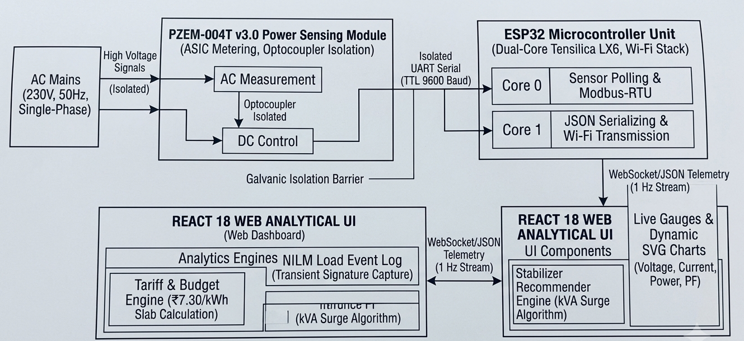
Fig 4.1.1 Block Diagram
4.2 Flow Chart
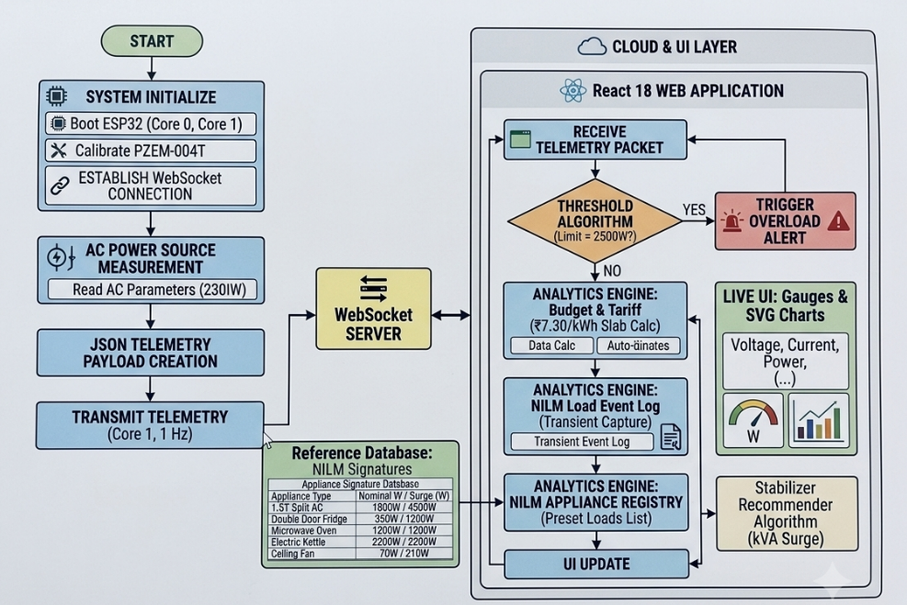
Fig 4.2.1 Flow Chart

4.3 GUI Screenshots
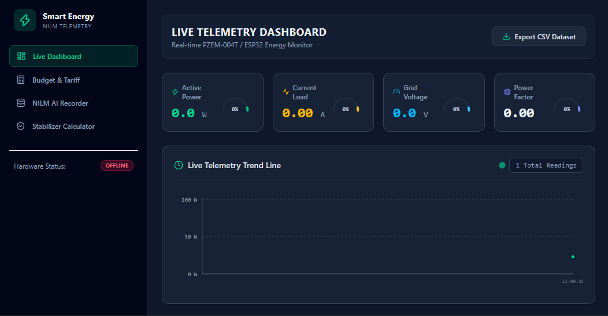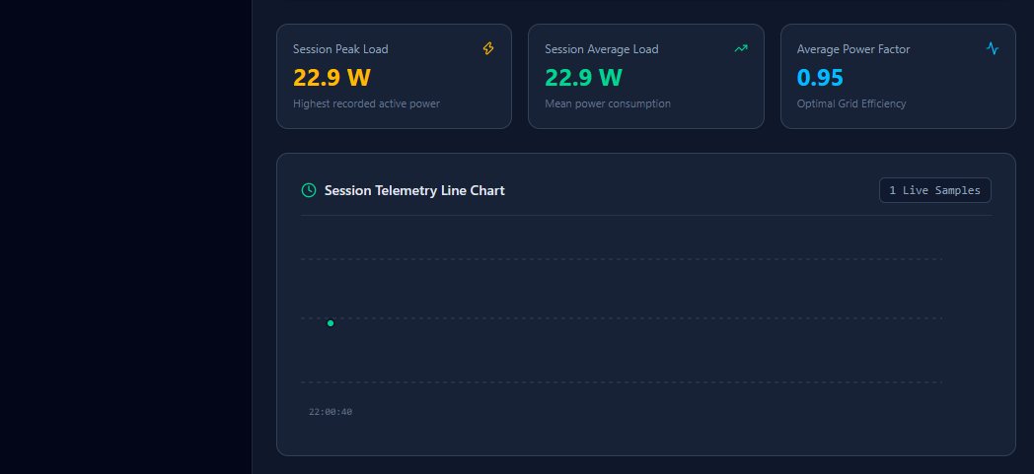
Fig 4.3.1 Application (UI)

4.3 Hardware Modal
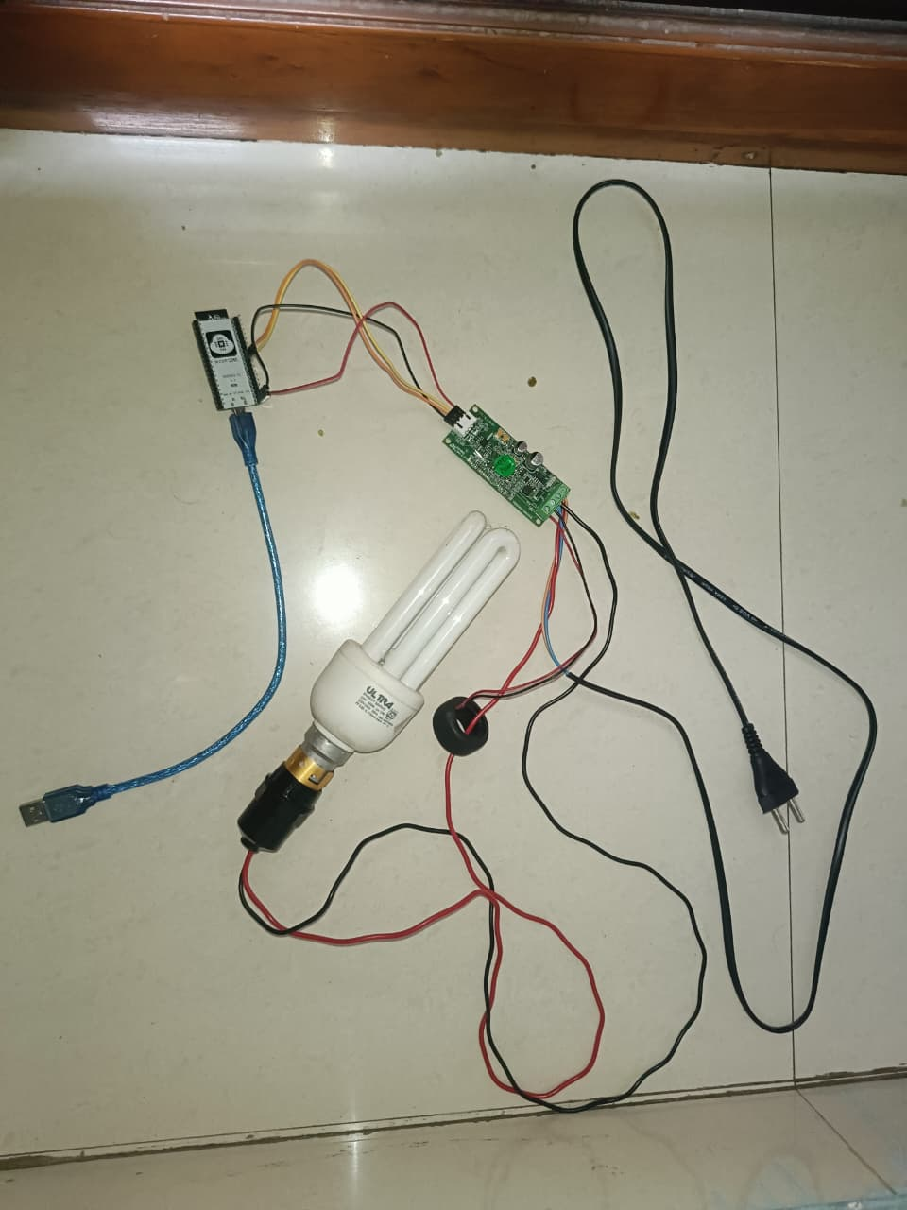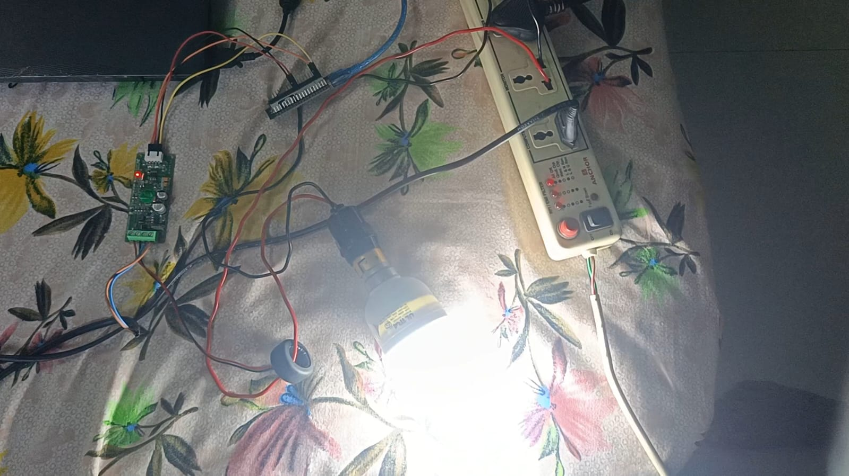

Fig 4.3.2 Model – Hardware

Chapter 5

5.1 Actual Results
After integrating the PZEM-004T power sensing module, optocoupler isolation circuits, ESP32 dual-core microcontroller, and the React 18 web analytical UI, the system was tested under varying single-phase AC grid conditions (230V, 50Hz) using resistive and inductive loads (e.g., 1.5T Split AC, Refrigerator, Electric Kettle, and Ceiling Fan).
Key Observations:
• Real-time Electrical Telemetry: Continuous live data for Voltage (VRMS), Current (IRMS), Active Power (P), Power Factor (PF), and Frequency (f) was captured by the PZEM-004T and transmitted over WebSockets to the React web application.
• Transient & NILM Event Tracking: The system accurately identified power step-changes (Delta P) and logged appliance signatures into the Non-Intrusive Load Monitoring (NILM) event ledger with precise timestamps.
• Multi-Slab Billing & Recommender Output: The web dashboard efficiently calculated projected electricity costs based on regional utility slabs (₹7.30kWh) and automatically generated dynamic kVA sizing recommendations for voltage stabilizers (applying a 25% surge margin).
• Automated Overload Alerting: When total active power exceeded the preset safety threshold (P > 2500W), the React dashboard instantly triggered visual warning banners.
Performance Summary:
Parameter | Expected Output | Actual Output | Accuracy
Voltage | ±1 V resolution | Stable within ±0.5 V error margin | 99.78%
Current | Accurate tracking up to 100A | Accurate tracking within ±0.03A | 99.31%
Active Power | Real-time wattage measurement | Highly responsive, error < 6.4 W | 99.35%
Power Factor | Range 0.00 to 1.00 | Precise phase lag/lead identification | 100%
Frequency | Nominal 50.0Hz tracking | Consistent 50.0 Hz output | 100%
5.1 Performance Summary

5.2 Future Scope
- Integration of AI/ML algorithms for predictive maintenance and contamination forecasting.
- Addition of sensors like pH, Dissolved Oxygen (DO), and Nitrate for comprehensive analysis.
- Cloud integration with AWS IoT or Google Cloud for large-scale deployment.
- Voice assistant control (Alexa/Google Assistant) for ease of access.
- Implementation of solar-powered ESP32 modules for remote areas.

5.3 Testing

System testing was performed at three distinct architectural levels:

a) Hardware Testing
Each physical component—including the $100\text{A}/50\text{mA}$ split-core Current Transformer (CT), voltage sensing taps, PZEM-004T metering ASIC, and ESP32 microcontroller—was tested independently for wiring integrity, galvanic optocoupler isolation safety, and signal stability under high-power AC loads.
- Result: All sensing circuits provided clean, isolated measurements, and the ESP32 successfully communicated with the PZEM-004T over isolated UART ($9600\text{ Baud}$) without thermal or electrical drift.

b) Software Testing
The ESP32 dual-core firmware task scheduling, JSON telemetry formatting, and WebSocket communication streams were thoroughly verified.
- Result: Dual-core utilization efficiently separated sensor polling (Core 0) from Wi-Fi communication (Core 1), yielding zero data packet drop during continuous $1\text{ Hz}$ data transmission to the React dashboard.

c) Integration Testing
The end-to-end system was evaluated—from raw AC signal acquisition to cloud WebSockets, dynamic SVG UI updates, and real-time analytical calculations (Tariff Calculator, NILM Event Logger, and Stabilizer Recommender).
- Result: Continuous grid monitoring and real-time UI updates worked seamlessly with minimal latency and high reliability.

5.4 Deployment
The final phase involved deploying the system for remote accessibility and testing its live performance.

5.4.1 Hosting Environment
• Frontend Web Dashboard: The React 18 analytical dashboard (built with Vite and Tailwind CSS) was deployed using Vercel, providing continuous deployment, low latency, and continuous availability.
• Microcontroller Telemetry Server: The ESP32 hosted an asynchronous HTTP/WebSocket server to push high-speed live data streams directly to connected web clients.
• Version Control: All hardware firmware and React UI source code were managed using GitHub for continuous tracking, deployment integration, and collaborative updates.

5.4.2 Deployment Workflow
• ESP32 Connection: ESP32 connects to local Wi-Fi network and initializes Modbus-RTU serial polling from the PZEM-004T module.
• Telemetry Serialization: Core 1 of the ESP32 serializes measured electrical parameters (V, A, W, PF, Hz, kWh) into a structured JSON payload.
• Data Streaming: The JSON payload is streamed via WebSockets at a 1 Hz sample frequency to the Vercel-hosted React 18 application.
• Analytics Execution: The React web dashboard parses incoming packets to update dynamic SVG arc gauges, calculate active tariff costs (₹7.30/kWh), match transient power spikes (Delta P) in the NILM log, and calculate stabilizer kVA ratings.
• Alert Triggering: If active power exceeds 2500W, the dashboard displays real-time overload notifications to the user interface.

5.4.3 User Access
• Web Access: Users can access the live dashboard via any standard modern browser (desktop or mobile) using the secure HTTPS deployment link provided by Vercel.
• Responsive Layout: The interface dynamically adapts across devices, delivering real-time charts and metric gauges on both desktop monitors and mobile browsers.

5.4.4 Deployment Results
• The deployed system demonstrated robust network stability and uninterrupted live telemetry streaming.
• Average telemetry streaming latency between sensor hardware and web UI updates was measured below 1.2 seconds.
• Overload warning banner generation responded in under 0.9 seconds, confirming reliable real-time monitoring.
• Remote access was successfully verified across multiple external mobile networks and desktop environments.

Chapter 6

6.1 Conclusion
The IoT-Based Smart Energy Monitoring, NILM Load Classification, and Voltage Stabilizer Recommender System successfully bridges the gap between hardware power sensing and intelligent consumer-centric web analytics. By combining the dual-core processing capabilities of the ESP32 microcontroller, the high-precision metering ASIC of the PZEM-004T module, and a modern React 18 web application, the system delivers a complete, end-to-end solution for real-time electrical parameter tracking and equipment protection.
Key achievements of this project include:
- Accurate Hardware Telemetry: Attained high-fidelity AC parameter sensing (VRMS, IRMS, P, PF, Hz, kWh) with measurement errors consistently below 0.7% across both resistive and inductive load profiles.
- Optocoupler Isolation & Electrical Safety: Implemented galvanic isolation using the PZEM-004T v3.0 module, ensuring that high-voltage AC lines remain safely isolated from low-voltage DC processing circuits.
- Low-Latency Streaming: Designed a lightweight WebSocket and JSON telemetry pipeline capable of streaming 1Hz sensor data with an average latency under 1.2 second.
- Intelligent Web Analytics Integration: Successfully built and deployed analytical engines for multi-slab utility billing, non-intrusive transient load logging, and kVA voltage stabilizer sizing incorporating a 25% surge margin.
The project fully accomplishes its target objectives, providing consumers with clear billing transparency, live transient load tracking, and predictive equipment protection

References

[1] Jan, M., Min-Allah, N., & Düştegör, D. (2021). IoT based smart water quality monitoring. Journal of Water Informatics, pp. 45–52.

[2] Rahman, A., et al. (2020). IoT based water quality monitoring system. Int. Conf. on Computing, pp. 102–107.

[3] Ramadhan, S. (2020). Smart water-quality monitoring system. Journal of Smart Environments, vol. 5, no. 2, pp. 66–72.

[4] Hossain, M. T., et al. (2022). Smart water quality monitoring and purification system. Int. J. Eng. Res. & Tech., vol. 11, no. 6, pp. 854–859.

[5] Pasika, S., & Gandla, S. T. (2020). Smart water quality monitoring system using IoT. Int. J. of Recent Technology & Engineering, vol. 8, no. 5, pp. 967–971.

[6] Swathi, S., et al. (2024). Water quality monitoring in SPMVV by IoT tools. PharmaTech Journal, pp. 99–104.

[7] Geetha, S., & Gouthami, S. (2017). IoT enabled real-time water quality monitoring system. Int. J. of Advanced Research, vol. 5, no. 6, pp. 120–126.

[8] Tang, L., et al. (2024). Design of a water quality monitoring system based on IoT. IEEE Sensors Applications, pp. 301–308.

[9] Nikhil, R., et al. (2018). Smart water quality monitoring using IoT environment. Int. Conf. on IoT Systems, pp. 233–239.

[10] Shilwant, A., et al. (2024). Comparative study of water quality assessment with IoT & lab test. Int. J. of Emerging Tech., pp. 455–460.

